Air Pressure, Temperature & Humidity — Sensor Research
LV Onboarding · Riddhi Gaddamwar · Formula Slug

Overview
One project, two applications on the racecar: (1) battery cooling — temperature, humidity, and ambient pressure; (2) aero element validation — pressure distribution vs CFD. The BMP180 (obsolete, fixed I²C address, no address pins) is the baseline: we need active parts with at least its pressure resolution that can be banked on one PCB, plus humidity where the BMP180 provides none.

BMP180 Baseline
MEMS absolute barometer; strong Arduino ecosystem; DigiKey 828-1027-2-ND (Obsolete). Fixed I²C slave address — only one per bus without a multiplexer.
Spec | BMP180
Pressure range | 300–1100 hPa
Pressure resolution | 0.02 hPa (= 2 Pa), ultra-high-res mode
Pressure accuracy | ±0.5 hPa relative (order ±50 Pa absolute class)
Temperature | −40 to +85 °C, ±1 °C
Humidity | None
Interface / banking | I²C only, fixed 0x77 — cannot stack identical chips on one bus

Application 1 — Battery Cooling Monitoring
Continuous cell temperature is safety-critical (60 °C limit). Aerometric sensing adds context: airflow path, outlet heating, and humidity (condensation / leak detection).
Parameter targets:
- Range — Temperature: −20 to +85 °C; Humidity: 0–100 % RH; Pressure: ~85–110 kPa absolute (ambient reference only)
- Resolution — Temperature: 0.1 °C steps useful for logging; Humidity: ~1 % RH steps; Pressure: hPa-scale is sufficient
- Accuracy — Temperature: ±0.5 °C or better; Humidity: ±3 % RH or better; Pressure: ±1 hPa class acceptable
- Integration — 2–3 physical locations → multiple sensors on one MCU (I²C; TCA9548A mux if many identical RH parts)

Application 2 — Aero Element Validation
The aerodynamics team provided a 2D rear-wing simulation labeled “Contours of Total Pressure [Pa].” The colorbar appears to span approximately −250 to +250 Pa. Before comparing measurements to the plot, I would confirm with the aero team whether these are gauge/relative values and what reference pressure the CFD uses. Total pressure and surface static pressure are not interchangeable.
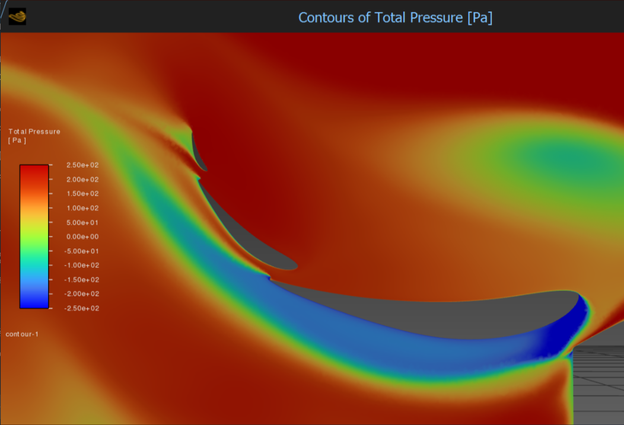
Figure — Rear-wing CFD contour labeled Total Pressure [Pa]; pressure reference to be confirmed.
What the image implies for sensor selection:
- Range: the displayed colorbar appears to span roughly −250 to +250 Pa. As a preliminary design target, measure at least ±300 Pa relative to an appropriate reference, with additional margin to be determined after confirming the CFD setup.
- Resolution: colorbar labeled in ~50 Pa steps, but smooth contours between ticks → need to resolve changes smaller than 50 Pa; target ≤10 Pa (ideally ≤5 Pa) on relative pressure after reference subtraction
- Precision (repeatability): matching CFD shape requires stable, repeatable readings across channels — often more important than absolute barometric accuracy; aim for consistent ΔP between taps run-to-run
- Accuracy: absolute barometer accuracy alone does not establish differential-pressure accuracy. Offset mismatch, sensor drift, tubing effects and the uncertainty of the reference measurement must be evaluated before claiming agreement with CFD.
- Channel count & rate: 5–10+ taps on one PCB; ~10–50 Hz logging per channel for autocross segments
Terminology used in this document:
- Range = span of pressures the system must represent (here, relative Pa on the wing)
- Resolution = smallest pressure change the DAQ can distinguish (limited by sensor noise + oversampling + reference subtraction)
- Precision = repeatability of repeated measurements at the same tap
- Accuracy = closeness to true physical pressure (secondary if we only compare CFD gradient shape)
Proposed implementation: use BMP390 absolute MEMS sensors over SPI, with a separate ambient reference channel, and calculate P_rel[i] = P_tap[i] − P_ref after channel calibration. This requires a validated pneumatic manifold or pressure-port interface: BMP390 packages do not provide built-in hose barbs. Dedicated differential-pressure sensors with tubing ports are an alternative. A flush wing-surface tap generally measures static pressure, while the supplied CFD plot is labeled total pressure; the aero team must confirm the intended comparison.

Example Dynamic-Pressure Check
At a representative speed of 80 km/h (22.22 m/s) and assumed air density ρ = 1.225 kg/m³, dynamic pressure q = ½ρv² = 0.5 × 1.225 × (22.22)² ≈ 302 Pa. This is a useful order-of-magnitude comparison with the contour’s apparent few-hundred-pascal variation, not proof that total or surface pressure at each tap equals q.

Sensor Output Interfaces (Multiple Identical Sensors)
Interface | Many of same part on one PCB | Notes
Analog | One signal per sensor → multiplexer + ADC | Good for DP elements; wiring noise on car
I²C | Fixed 7-bit addresses | BMP180 problem; use mux or parts with address pins
SPI | One CS pin per sensor, shared CLK/MOSI/MISO | Best for 5–16 identical barometers — recommended for aero array
OneWire | Unique ROM IDs | Rare for pressure; poor fit in noisy EV environment
Battery nodes: I²C. Aero array: SPI with independent chip-select per BMP390.

Sourced Sensors (DigiKey / Mouser)

Bankable BMP180 replacement — pressure (aero array)
- Bosch BMP390 — sub-pascal digital pressure resolution (measurement noise and relative accuracy are separate specifications); SPI + I²C; 2×2 mm LGA; DigiKey 828-BMP390CT-ND (verify stock, datasheet operating mode and calibration needs).
- STMicro LPS22HHTR — backup; SPI; ~0.65 Pa noise; DigiKey 497-LPS22HHTR-ND

Temperature & humidity (battery cooling)
- Sensirion SHT41-AD1B-R2 — ±0.2 °C typ., ±1.8 % RH typ.; I²C; DigiKey 1649-SHT41-AD1B-R2CT-ND
- Optional co-located BMP390 for correlated pressure + temperature at each cooling node

Custom Pressure Sensor Array (Build-Your-Own)
- KiCad PCB with 8–12 BMP390 devices: shared SPI bus, unique CS each, local decoupling, JST or header to LV DAQ
- Pneumatic: wing pressure taps → short tubing → purpose-designed, sealed pressure manifold or an appropriate ported differential sensor; protect the PCB from water and debris. Do not attach tubing directly to an unmodified BMP390 package.
- Reference: use a carefully located ambient/static reference tap, with synchronized readings and calibrated channel offsets; reference placement must be reviewed with the aero team.
- If CS pins are limited: MCP23S17 SPI GPIO expander
- “True” scratch-built MEMS is not feasible; learning alternative = commercial DP element + instrumentation amp + 24-bit ADC

Calibration & Validation Plan
1. Expose every channel to a common known pressure; record and correct per-channel offsets in firmware.
2. Check at more than one known pressure to assess gain error; repeat across expected operating temperatures to quantify drift.
3. Compare the array against a calibrated reference instrument, including the tubing/manifold, and assess repeatability, noise, response time and leaks.
4. Log vehicle speed and reference pressure alongside sensor data. Confirm that the CFD quantity and physical tap geometry are comparable before interpreting differences as aerodynamic-model errors.

Key Parameters — Design Summary
 | Battery cooling | Aero (from CFD contour)
Range | −20–85 °C; 0–100 % RH; ~85–110 kPa abs. | ±300 Pa relative (CFD shows ±250 Pa)
Resolution | 0.1 °C / ~1 % RH steps; coarse P | ≤10 Pa on ΔP (≤5 Pa ideal)
Precision / accuracy | ±0.5 °C, ±3 % RH | Repeatable ΔP across taps; abs. baro less critical
Parts | SHT41 (+ optional BMP390) | BMP390 × N on SPI

Design Considerations and Remaining Validation Requirements
- CFD comparison: the provided contour represents total pressure, while flush-mounted wing taps typically measure static pressure. A corresponding surface-static-pressure CFD output or suitable total-pressure probe arrangement is required for a valid comparison.
- Validation objective: compare measured pressure gradients with CFD predictions; calculating aerodynamic loads requires additional calibration and spatial integration.
- Sensor count: the initial 5–10+ measurement-point target determines SPI chip-select requirements and any GPIO expansion.
- Battery cooling placement: distribute temperature/humidity nodes across inlet and outlet air paths, with final locations coordinated with the mechanical and battery teams.
- Sourcing contingency: confirm BMP390 availability before ordering; LPS22HH is an SPI-capable alternative subject to a separate performance and packaging review.
- PCB partitioning: separate battery-environmental and aero-pressure boards are preferable if their placement, pneumatic interfaces, or wiring requirements differ.

